Pr Providing specialist care
For your loved ones

Ascot Care 3rd Edition Newsletter

Welcome

Ascot Care would like to welcome you to our 3rd edition of our newsletter.

Ascot Care is a family run business that has provided specialist care for the elderly for over 30 years within our 6 care homes across the North East.

With ongoing training our staff continues to provide the highest level of care to suit each resident’s individual requirements/needs.

Newsletter Contents

- News
- Forth coming Events
- Training
- Birthdays
- Contact Details

News

Armed Forces Day 21st June 2015

Ascot Care families enjoyed attending Armed Forces Day 2015 in various events across the North East.
Georgia a daughter of one of our Directors had a fun afternoon in Seaburn…….

Saluting Our Soliders Climbing the wall Fun on the fair

Day Trips Out & Events

Our Residents enjoyed various trips out and events planned at their homes during the past month…

Springfield Lodge Residents:

Visited Beamish to the new cottage where they have started holding afternoon sessions for the elderly and dementia suffers.

Other Residents enjoyed a trip to Whitby for a fish & chip lunch

Springfield Lodge were visited by West Rainton Primary School who visited residents for Father’s Day, enjoying stories from the past.

A bar-b-que was arranged for 4th July American Independence day with a mixture of country and western songs.

St Anne’s

Residents have enjoyed a variety of events over the past few weeks:

Pub Quiz attended by families and staff with the winning team “Desperate Housewives”

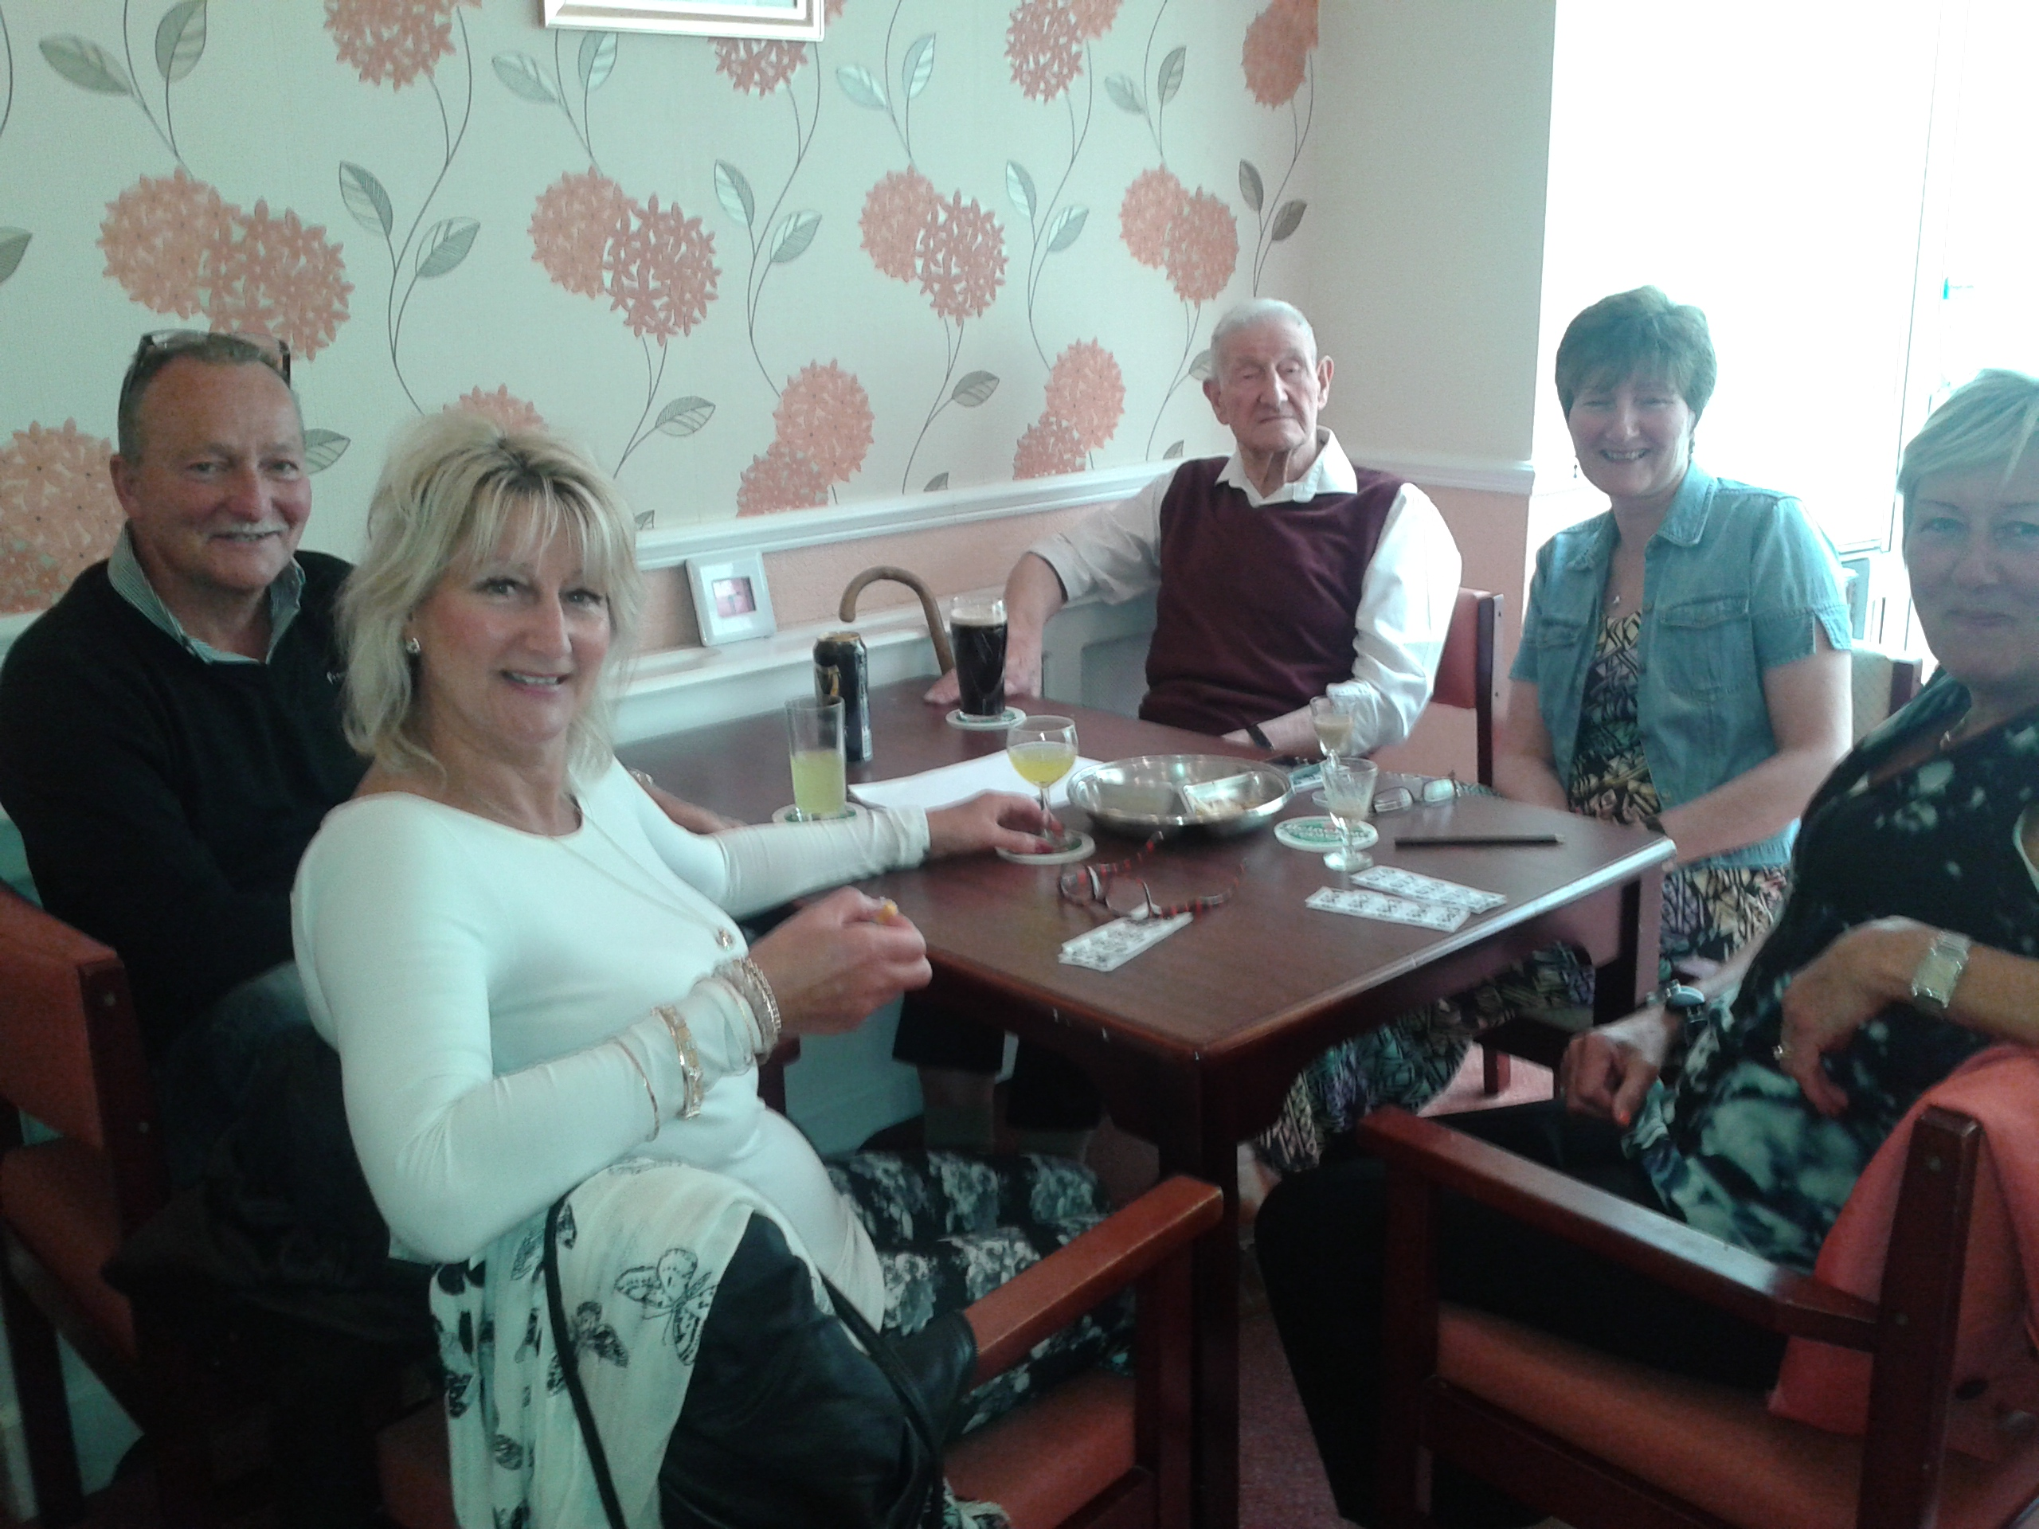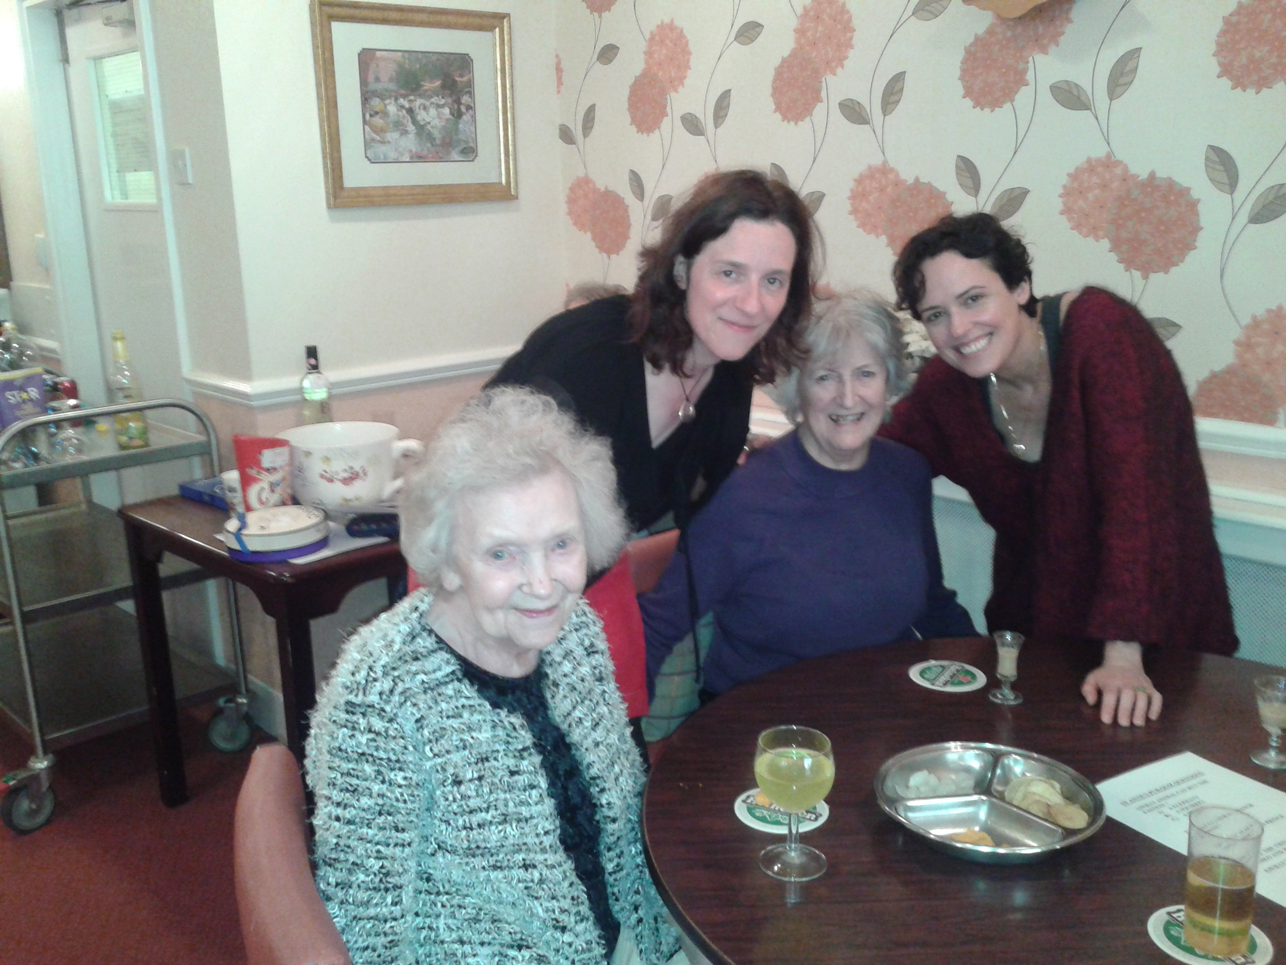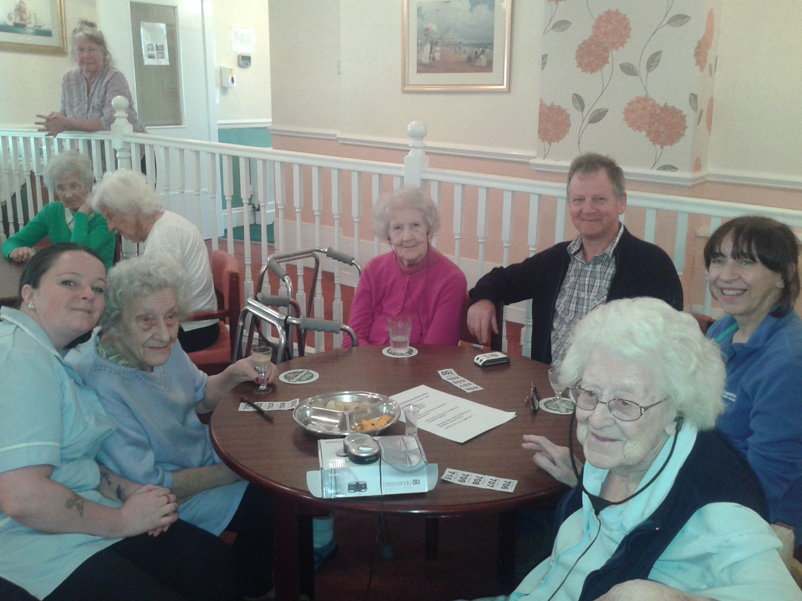

Care Home Open Day (Intergenerational with Rockcliffe School), the school children sang to our residents and then the residents sang to the school children and shared stories.
This was followed the following week when some of the residents visited Rockcliffe school for more entertainment by the children.

Father’s Day was a special day for residents who were visited by family members who enjoyed cream cakes and a beer.

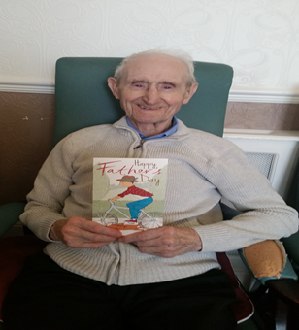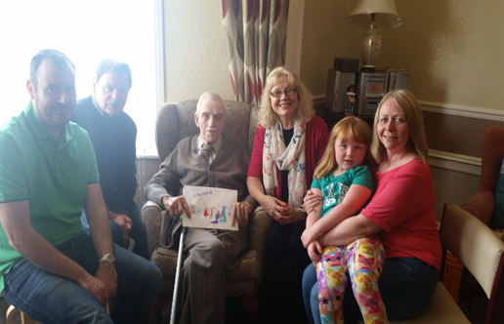

St Anne’s Continued:

Carers Week was celebrated by our residents who made Thank You cards & handmade flowers out of tissue paper to give to staff members.

Farm Trip where both residents and staff had a lovely day petting animals and a picnic at White House Farm.

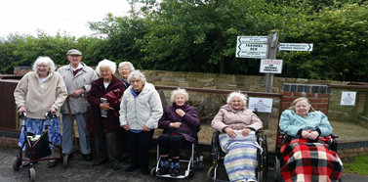

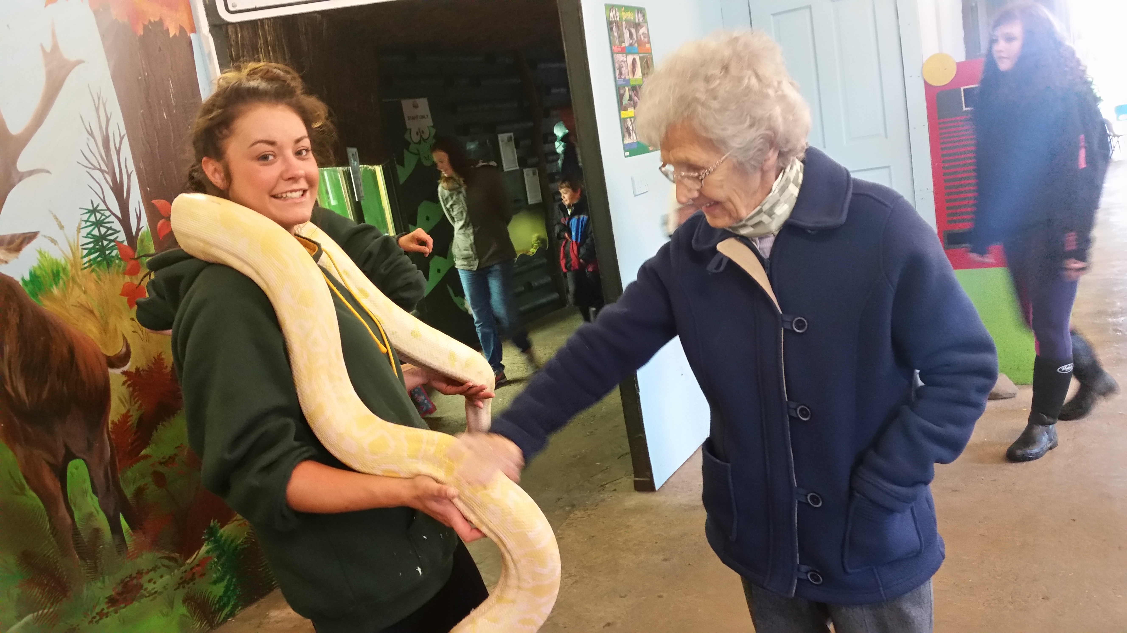

Birthday Celebrations:

Staff and family members ensured Muriel Gardner had a 105th birthday to remember by having afternoon tea, cakes and balloons.

Muriel was very pleased not only to appear in the local newspaper but receiving a birthday card by The Queen.

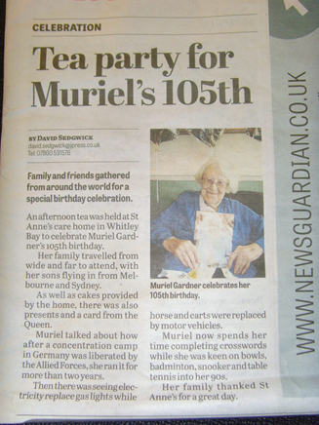

Westoe Grange

Residents held a Wimbledon Tennis afternoon with strawberries and cream

Forth Coming Events

Continuing with our summer events Residents can look forward to …………

Springfield Lodge: Residents will enjoya trip to South Shields and the beautiful beach

Westoe Grange: Summer Fayre, August 5th 2pm any donations welcome for the raffle, tombola

St Anne’s: Trip to Royal Quays, Stephenson Railway, Fish Quay for fish & chips lunch, Church visiting for Holy Communion.
Summer Fayre Satirdya 15th August a fun filled day for all the family to enjoy, bouncy castle, birds of prey, cakes, hooks a duck, raffles, tombola and plenty more

Daily activities at the homes, chairobics, sing alongs, film afternoons, board games

Charity Event

Ascot Care continues to support charity events with Directors and Staff attending The Gorillas Summer Ball in August in aid of Hire A Hero.
For details on this event and ways to support a charity close to us please click on the link below…..

http://www.pitchero.com/clubs/hireaherorugby/news/gorilla-ball-1446986.html

Training

Many of our staff members have or will be attending the following training courses which are held in our training rooms around the north east, by our qualified and highly professional training staff.

We currently have additional spaces that are available on the moving and handling and first aid courses, these are made available to care staff from other care homes as well as carers in the private home care sector.

For more information on spaces we have left or on courses we can provide for your own staff please email: lianneohara@ascotcare.co.uk

Equality & Diversity Training
First Aid Training
Person Centred Training
Dementia Friends Training
Sensory Awareness Training
Staff continue to work towards completing NVQ
Congratulations to Joeanne at St Anne’s who has completed her NVQ Level 5

Testimonials

St Anne’s have received 2 lovely cards from families thanking them:

“Muriel Gardner celebrated her 105th birthday on 17/05/15 at St Anne’s and we would like to thank all the staff at St Anne’s, for the afternoon tea, cakes and balloons and warm welcome to Muriels family and friends at her celebration”
(Muriel Gardners Family)

“You are all just wonderful ! fantastic staff, what would we do without your care and support”
(Lorna Hill)

New Staff Member’s

Ascot Care would like to welcome our new staff members to our team, we look forward to working with you.

Vicki Jackson – Care Assistant
Sonia Porter – Care Assistant
Emily Pearce - Care Assitant
Elizabeth Capewell – Assistant Manager for Westoe Grange
Birthdays

Birthdays are a very special day for everyone so our managers ensure we celebrate a resident’s birthday the way they like. We provide cake, balloons and ensure the birthday person has an enjoyable day.

Ascot Care would like to wish our residents & staff below a very special “Happy Birthday for
July”

Residents: Staff Members:
Ronald Mitchell Julie Charlton
John Richardson Doreen Simpson
Lily Gibbon 83 years old Zara Burns
Dorothy Higgins 95 years old Emma Martin
Helen Dixon 93 years old Shelly Young
Muriel Slaney 91 years old Tony Hopkins
Elsa D’Arcy 92 years old Jacqui Lowden
Penny Chappell 93 years old

Contact Details

The Gardens: Westoe Grange
Pond Field Close 4 Horsley Hill Road
Salutation Road South Shields
Darlington Tyne & Wear
DL3 8LH NE33 3DY

Tel: 01325 487777 Tel: 0191 493 6920
Manager: Marie Nicholson Manager: Carole Blackett

St Anne’s The Lawns
1-4 Rockcliffe 1-2 Kensington Gardens
Whitley Bay Monkseaton
Tyne & Wear Tyne & Wear
NE26 2BG NE25 8AR

Tel: 0191 252 9172 Tel: 0191 253 0291
Manager: Bev Allan Manager: Kevin Bailey

Castleview Springfield Lodge
Howling Lane North Street
Alnwick West Rainton
Northumberland Co Durham
NE66 1LH DH4 6UN

Tel: 01665 605 311 Tel: 0191 584 2805
Manager: Stephen Dunn Manager: Debby Atkinson

Or please visit our website at www.ascotcare.co.uk

