Providing specialist care
For your loved ones

Welcome

Ascot Care would like to welcome you to our 5th edition of our newsletter.

Ascot Care is a family run business that has provided specialist care for the elderly for over 30 years within our 6 care homes across the North East.

With ongoing training our staff continues to provide the highest level of care to suit each resident’s individual requirements/needs.

Newsletter Contents
- Recent Events
- Upcoming events
- Refurbishment
- Birthdays

11.11.2015

Recent Events

October saw our residents enjoy Halloween themed events across our
Homes with parties, entertainment and Castleview also held a raffle &
Tombola raising £150.00 for their resident’s fund.

Resident Charlotte Hopper won 1st prize raffle of lunch for 2 at Eshott Hall

Entertainment at St Anne’s Family Party at Castleview
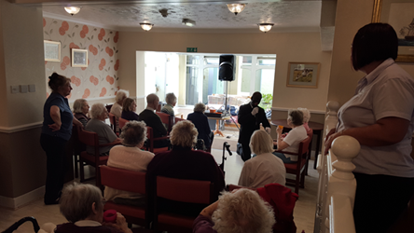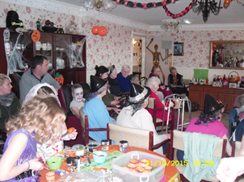

Entertainer at Castleview Children decorating cakes
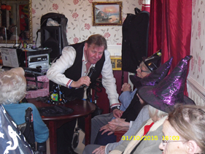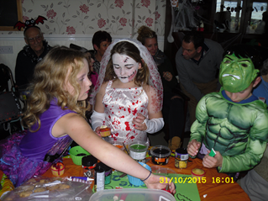

Residents Enjoying the fun
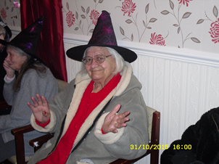

Remembrance Sunday

Our residents & staff marked Remembrance Sunday wearing their poppies
With pride, watching the service at Cenotaph on TV. On 11.11.2015 at 11am Residents held a 2 minute silence.

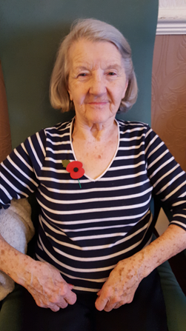

Upcoming Events

Our residents can look forward to the upcoming events at our homes….

- Clothes party
- November communion service
- Avon party
- School children Christmas carols
- Christmas parties
- Chairobics
- Alnwick town Christmas lights switch on
- Christmas arts & crafts
Refurbishment at Our Homes

Our workman and contractors have been very busy with the extensive
Work that has been carried out across our homes, with great feedback
From our residents and their families.

Westoe Grange: a new carpet fitted throughout the ground floor

Castleview: have commenced work on new flooring throughout the whole
Of the care home

The Gardens: their new conservatory is fully completed with new
Fire place, new furniture at the entrance. The bar area has been moved to the
lounge area of the new extension.
The garden area has been replanted with plants and new seating added

St Anne’s: new flooring in the dining room with the garden and court yard having a makeover with new plants and seating.

The Lawns: decorating has started. The entrance and hallway being carpeted and new flooring have been laid in the dining room. The garden and court yard have also seen improvements with new paving, plants and seating added.

Wishing our residents and staff a very happy birthday, wishing you a special birthday.

Fiona Mellon administrator who advised she is celebrating her 21st again & again
Julie Ingram
Rachel Telfer
Yvonne Hassan
Joeanne Nicholson
Lesley Attrill

Robert Boyd 99 years old
Jeannie Faber 86 years old
Audrey Waters 86 years old
Betty Hill 98 Years old
Marlene Wood 79 Years old
Nancy Hudspith 101 years
Contact Details

The Gardens: Westoe Grange
Pond Field Close 4 Horsley Hill Road
Salutation Road South Shields
Darlington Tyne & Wear
DL3 8LH NE33 3DY

Tel: 01325 487777 Tel: 0191 493 6920
Manager: Marie Nicholson Manager: Carole Blackett

St Anne’s The Lawns
1-4 Rockcliffe 1-2 Kensington Gardens
Whitley Bay Monkseaton
Tyne & Wear Tyne & Wear
NE26 2BG NE25 8AR

Tel: 0191 252 9172 Tel: 0191 253 0291
Manager: Bev Allan Manager: Kevin Bailey

Castleview Springfield Lodge
Howling Lane North Street
Alnwick West Rainton
Northumberland Co Durham
NE66 1LH DH4 6UN

Tel: 01665 605 311 Tel: 0191 584 2805
Manager: Stephen Dunn Manager: Debby Atkinson

Or please visit our website at www.ascotcare.co.uk

