Pr Providing specialist care
For your loved ones

Ascot Care 4th Edition Newsletter

Welcome

Ascot Care would like to welcome you to our 3rd edition of our newsletter.

Ascot Care is a family run business that has provided specialist care for the elderly for over 30 years within our 6 care homes across the North East.

With ongoing training our staff continues to provide the highest level of care to suit each resident’s individual requirements/needs.

Newsletter Contents

- News
- Forth coming Events
- Training
- Birthdays
- Contact Details

News

Ascot Care staff continued to show their support for various charities by baking, running, golfing and dancing to help raise money and awareness for different charities, a BIG THANK YOU to everyone as over the past few months you have helped raised thousands of pounds which will make a big difference.

Barclays Tea & Cake morning
A big thank you to all our homes and staff and the Coop store in Alnwick that baked a variety of mouthwatering cakes to be sold at Barclays Call Centre. The cakes were a huge success and along with the raffle raised £1044.00.

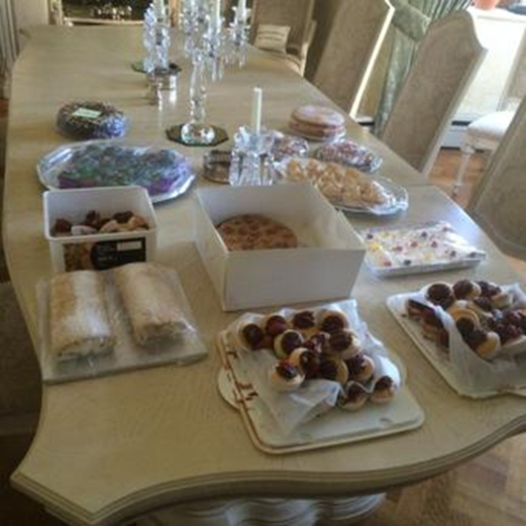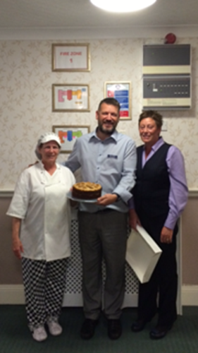

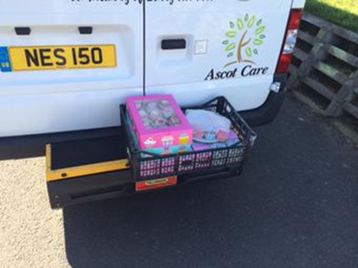

Ascot Sponsor Mowden Golf Day

Ascot Care was proud to support and sponsor Mowden Park Rugby golf day held at Rockcliffe Hall.

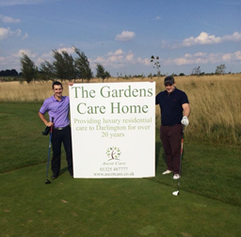

Charity Run’s

During September Lianne O’Hara (Accountant Head Office) and her Daughter Georgia put on their trainers for 2 charity runs.

Herrington Park Colour Run – 5KM Raising money for Grace House.

Before After
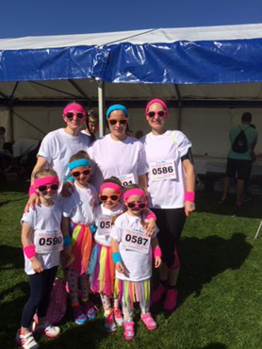

Great North Mini Run – 1KM

Georgia ran for Hire a Hero and even though it was pouring with rain had a great time at the event in Newcastle and has already signed up for next year.

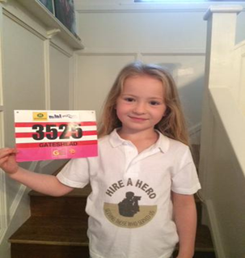

Gorilla’s Charity Ball

Directors from Ascot Care attended the annual Gorillas Rugby summer Ball held in London for Hire a Hero. Everyone had an amazing evening while raising funds and awareness for a great military charity.

Trevor & Gareth Nesbit with Hire a Hero CEO Gerry Hill

Checking out the auction Gorillas Mascot dancing away Smile

Aspire Charity Swim

Vicky Jenkins Ascot Care Agency is taking part in the Aspire charity swim, which are raising money for people with spinal injuries.

The event began on Monday 14th sept and will run for 12 weeks. Vicky must swim the equivalent of the channel in this time which is 22 miles (32 lengths of the pool = ½ mile ) so far she has raised £117 and would like to achieve £450.

If you would like to support Vicky and make a donation please use the below Aspire website.

http://www.aspirechannelswim.co.uk/

Good luck to Vicky and a BIG thank you to all our staff and families that have contributed and helped raise money for all the various charities over the past few months.

Events

CastleView
Congratulations to all our Staff at Castleview Care Home who scored maximum points on their Quality Monitoring visited conducted by Northumberland County Council.
Manager Stephen Dunn was advised that this top score has never been achieved before, well done to all excellent achievement.

Gardens
Held a coffee/tea morning for residents and their families called Teath Event, giving advice about oral hygiene.

Westoe Grange
Residents have been enjoying day trips out to the Winter Gardens & Morpeth, while other residents have been enjoying afternoon tea, puzzle afternoons.

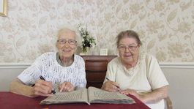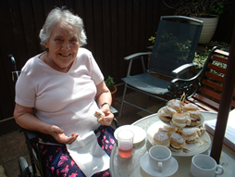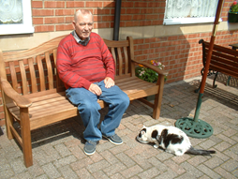

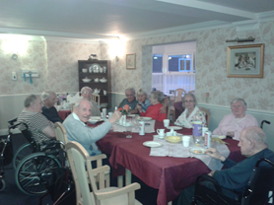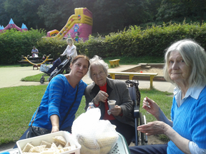

Upcoming Events at our Homes

Cheese & Wine Afternoon
Pumpkin Carving
Halloween tea
Halloween Party with raffle/tombola/games
Remembrance Sunday

Birthdays

Birthdays are a very special day for everyone so our managers ensure we celebrate a resident’s birthday the way they like. We provide cake, balloons and ensure the birthday person has an enjoyable day.

Ascot Care would like to wish our residents & staff below a very special “Happy Birthday “

Residents:
Julia Lang
Stanley New
Jen Goddard
Ellen Walton who celebrated her 102nd birthday in September
Rennie Proud
Bob Maddison

Welcome from Ascot Care to our new staff member who has joined our team….

Joanne Pringle at the Lawns Home
Tanya Swordy
Jen Gomm

Contact Details

The Gardens: Westoe Grange
Pond Field Close 4 Horsley Hill Road
Salutation Road South Shields
Darlington Tyne & Wear
DL3 8LH NE33 3DY

Tel: 01325 487777 Tel: 0191 493 6920
Manager: Marie Nicholson Manager: Carole Blackett

St Anne’s The Lawns
1-4 Rockcliffe 1-2 Kensington Gardens
Whitley Bay Monkseaton
Tyne & Wear Tyne & Wear
NE26 2BG NE25 8AR

Tel: 0191 252 9172 Tel: 0191 253 0291
Manager: Bev Allan Manager: Kevin Bailey

Castleview Springfield Lodge
Howling Lane North Street
Alnwick West Rainton
Northumberland Co Durham
NE66 1LH DH4 6UN

Tel: 01665 605 311 Tel: 0191 584 2805
Manager: Stephen Dunn Manager: Debby Atkinson

Or please visit our website at www.ascotcare.co.uk

